Welcome to the Cody’s Original Roadhouse Hourly Training Program. We are excited for you to be a part of our team and to teach you everything we can in order for you to be a success at Cody’s. Please fill in the facts below so that you can have the proper information if something is to arise during your training process. Please bring this study guide and quiz packet to class every day.
Cody’s Original Roadhouse Restaurant Information

1. MANAGEMENT STAFF:
GENERAL MANAGER: ___________________________ MANAGER: ___________________________
MANAGER: ___________________________
KITCHEN MANAGER: ___________________________

2. ADDRESS: _______________________________________________________

3. PHONE NO: _____________________

WEBSITE ADDRESS: www.codysoriginalroadhouse.com

4. HOURS OF OPERATION:
OPEN 7 DAYS PER WEEK
Monday thru Thursday: 3:00 PM - 10 PM
Friday and Saturday: 3:00 PM – 11 PM
Sunday: 11:00 AM - 10 PM
NOTE: Opening & Closing times may vary – check your restaurant hours.
NOTE: Restaurants Restaurant is always ready 15 minutes prior to opening. Also, will stay open 15 minutes past posted closing time.

Training Schedule for the Week
 | Date | Time | Trainer
Day 1
Day 2
Day 3
Day 4

Prep Training Process Overview
Training times:
8/9:00-8:15/9:15 Set-up of area with Trainer
8:15/9:15-1:45 Hands on Experience
1:45-2 Clean-up of area with Trainer
2:00-2:45 Class with food show, Quiz review, Evaluation

Day 1
Class Topics-
- Prep Cook Function and Responsibilities
- The Mechanics of the Prep Station
- Prep Sheet
- Weight vs Volume
- Recipe Books
- Minimum Safe Internal Cooking Temperature and Times
Follow Topics-
- Round Robin: 30 minutes in each area. MEAT ROOM, PANTRY/GRILL/FRY/FLAT TOP, EXPO
- Meat Room- Observe meat cutting techniques, meat cutter responsibilities including marinating of chicken/beef, pull thaws, and view all hand cut steaks
- Pantry/Grill/Fry/Flat Top - Observe proper mechanics, communication, plate set up, and flow of kitchen
- Expo- Manager and/or Expo in window out explains Picture Perfect Plate Presentations and menu descriptions
Cody’s Signature Dishes to Share During Classroom-
- Order your choice of 2 signature Cody’s dishes to share: 10oz Sirloin Steak, ½ Rack Baby Back Ribs, Roadhouse Chopped Steak, or 12oz Slow Roasted Prime Rib of Beef

Prep Cook Functions & Responsibilities

Your role as a Prep Cook at Cody’s Original Roadhouse is extremely important to our success. Your speed and efficiency are imperative to the smooth operation of the kitchen. You need speed to successfully complete your tasks. Your efficiency and consistency will help assure 100% guest satisfaction. You will be provided with high quality products and the necessary tools and equipment to complete your daily duties.

General Job Guidelines and Responsibilities
      - Always arrive at least 5 minutes before your scheduled time.
      - Always come to work with a clean uniform.
      - Check your duties for the day by reviewing prep list, cooler pull list, etc.
      - Get organized and plan your day before beginning your work.
      - Sanitize and clean your work area.
      - Clean as you go - maintain a clean station and work area.
      - Follow the recipes - ensure the quality and consistency of every batch recipe that goes from our prep kitchen to the proper workstation on the line.
      - Be a team player - support and assist your fellow team members whenever possible.
      - Ensure that all slicers, scales, refrigeration and cooking equipment are operating correctly and at the proper temperature.
      - Report any broken or malfunctioning equipment to the Management team.
      - ALWAYS follow safe food handling practices.
      - Maintain your daily and weekly sanitation and maintenance schedules.
      - Never store raw poultry, meat or fish products above cooked or ready-to-eat products.
      - Maintain a safe, clean and organized workstation and walkway in the prep areas.
      - Use our product labeling system to label, date, rotate and store all food products.
      - Prepare only what is on the Daily Prep List.
      - Clean all equipment and workstations immediately after use.
      - Always check with a manager prior to clocking out.

The Mechanics of Prep
- Clock in.
- Get apron and towel.
- Wash hands.
- Set up sanitizer bucket with towels and sanitize work area. Label sanitizer bucket with date and times.
- Get organized - assemble your tools including cutting board, scale, knives, pans, measuring tools, etc.
- Review Prep List - prioritize; determine what products are needed to open. (Note any 911 items)
- Begin working on Prep List items.
- Note par vs on-hands (prep needed) as noted by kitchen manager.
- Follow recipe book.
- Follow proper measurements.
- Follow proper preparation methods.
- Store the finished prepped item in its appropriate container.
- Ensure each item is labeled and dated.
- Follow FIFO procedures when storing items.
- Follow Health and Safety guidelines
- Don't work on too many items at one time. Limit yourself to 2 products at once.
- During the shift (if applicable), provide backup for anything needed on the line. Assist cooks as needed.
- Maintain a clean work area - clean as you go.
- Clean the equipment used after each use.
- When all Prep List items are complete, have kitchen manager review and check out.
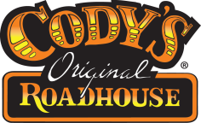

Qualities of a Good Prep Cook
Efficiency and Speed A good Prep Cook must work quickly and efficiently to provide the quantity of products needed to keep up with our volume of business.
Organization and Focus A good Prep Cook stays focused on one or two tasks at a time and completes those tasks before moving on to something else. The workstation is not cluttered. When one task is finished, utensils tools and equipment are cleaned and put away if not needed.
Cleanliness and Sanitation Much of a Prep Cook’s job is involved with maintaining standards of cleanliness in the kitchen. A good Prep Cook must be aware of our cleaning and sanitation standards and must maintain them consistently.
Always a Team Player A good Prep Cook is always aware of what’s going on in the kitchen and is ready and willing to help others get the job done.
Prep Sheet
The prep sheet is a tool used daily in each department. A prep sheet is completed daily by the Kitchen Manager. The kitchen manager will record his or her “on-hands” (the number of product on the shelf) and “prep amounts” (the amount of that item that they will need to make for the day). Depending on the current “par levels” (the predetermined number based upon historical trends, days of the week, and previous week’s usage) certain product may or may not need to be prepped today. Use only approved recipes when prepping. Prep is mainly done during the day, but some items might need to be made during the PM shift also. Note 9-1-1 items. These are items which need to be made first. Ensure only the amount which the manager records are the amount that is made. By making less or more of an item can affect the shift and the amount of product for the day. If fewer products are made, there is a likely chance that the food items will run out. If more product is made, there is a chance that the product will need to be disposed of because it will not be used before its expiration.

Weight vs Volume
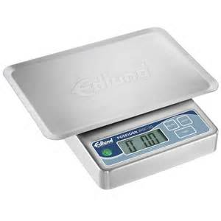
Weight: Scales are important tools that need to be used when any recipe needs to be portioned. It is essential that all products are weighed accurately to ensure consistency, proper sized portions, and controlling food costs. Scales are used to accurately measure specified amounts or portions of a product for prep or serving.
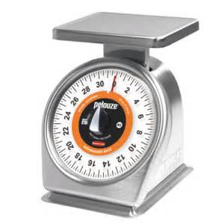
There are 2 types of scales:
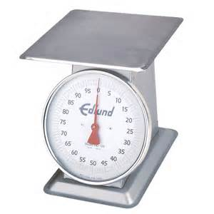
1. Pound Scale- measures weight in pounds
2. Ounce Scale- measures weight in items of 2 pounds or less
Each of these dial scales are in a dial and digital version.

There are four main parts to a dial scale:
1. The dial indicates the setting
2. The needle points to the weight of the product
3. The adjusting screw is used to adjust and set the needle for proper weight/portioning
4. The Platform is where the item to be weighed or portioned is placed. Never set food directly on the platform. Use paper, plastic, a sav-a-day, or a container.
* In order to weigh or portion the correct amount, weight allowance must be made for the container being used to hold the product. To make this adjustment, place the empty container on the platform and turn the adjusting screw until the needle points to “zero”. It is now ready to being weighing/portioning. Or if using a digital scale, place the empty container on the platform and push the “tare” button to zero out the scale. Now you can place the product in the container to get the proper weight.

Cleaning a scale:
The person using the scale is responsible for rinsing and sanitizing it by hand immediately after use. Never run a scale through the dishwasher.

Storing a scale:
Place the scale on the designated shelf. Never stack or store anything on top of the scale. To prolong the life of your scale, always pick it up by the base, never the platform.
Volume: Measuring utensils are important tools that need to be used when any recipe needs to be portioned. It is essential that all products are measured accurately to ensure consistency, proper sized portions, and controlling food costs.

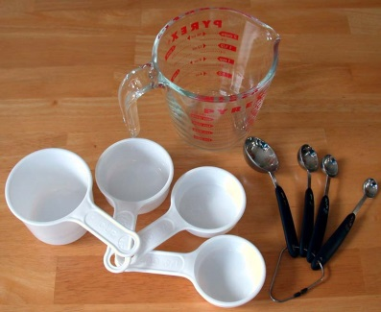
Utensils are used to accurately measure specified amounts or portions of a product for prep or serving. There are several types of utensils. To name a few:
1. Tsp
2. Tbsp
3. Cup
4. Pint
5. Quart
6. Gallon

There are 5 main parts to using measuring utensils:
1. Know the difference between liquid and dry measures and use the appropriate one for each task. While they hold the same volume, they are used differently. Measurements are labeled on each measure.
2. Use liquid measure for liquids, such as water, milk, or oil. Fill the cup to the appropriate line, place it on a level surface, and read it with your eye at the level of the liquid. Water surface curves downward, so use the bottom of the curve for accurate measurement and not the edge that is against the measuring cup. This is helpful in bread recipes where the exact amount of water is crucial.
3. Use dry measure for powders, such as sugar, salt, and baking powder. Spoon or scoop the powder lightly into the cup. Run a knife or spatula across the top to level the surface and scrape any excess back into the jar or canister.
4. Use liquid measure for any liquids by measuring it into a measuring spoon and filling it full.
5. Measure a “heaping” or “rounded” tablespoon, teaspoon, or (less frequently) cup. This quantity is not so precise, but it is generally a moderately sized, round mound, or heap of the dry ingredient in addition to that which fills the spoon.

Note: There is a difference of measurements with weight and volume. Weight is something you put on a scale to weigh; volume is something you put in a utensil of measurement. As Albert Einstein asked, “Which weighs more, a ton of feathers or a ton of bricks?”
The answer is they both weigh the same. A ton is 2000lbs. If you put a ton of feathers and bricks on a scale you would certainly use less bricks and more feathers to get to a ton of weight. The same goes if you would put an ounce of bricks on a scale to weigh vs an ounce of bricks measured in volume. You would not have the same amount of bricks on each of the measurement tools.

(Prep) Recipe Books

All recipes for each item we make are listed in the Prep Recipe book. The book is tabbed at the bottom in order for you to find the product quickly. It is in the following order: Beef-Chicken-Pork, Dairy-Eggs, Dressing-Sauces-Gravy, Produce, Seafood, Sides-Starches, Desserts-Rolls-Soups, Sunday Specials, Monthly-Holiday Specials. In order to create a product that is consistent every day, the item needs to be made exactly to the recipe spec. The reason we want consistency is so a guest will get the exact same item and same taste at any location.

Each recipe will contain the following
information:

Title of the Recipe

Shelf Life

Batch Size and Yield

Ingredients Needed
with spec amounts/measurements

Note: If anything is in yellow highlight,
this is something that has been
changed since the previous version.

MINIMUM SAFE INTERNAL COOKING TEMPERATURES AND TIMES
Cook each food to at least its minimum safe internal temperature and for at least the time indicated, to avoid food borne illness:
FOOD ITEM | MINIMUM SAFE INTERNAL TEMPERATURE
Poultry | 165º F (73.9ºC) for 15 seconds
Ground meats (including ground beef and ground pork) | 155ºF (68.3ºC) for 15 seconds
Pork, game animals, comminuted fish and meats | 155ºF (68.3ºC) for 15 seconds  150ºF (65.6ºC) for 1 minute  145ºF (62.8ºC) for 3 minutes
Beef Roasts | 145ºF (62.8ºC) for 3 minutes  140ºF (60ºC) for 12 minutes  130ºF (54.4ºC) for 12 minutes
Fish, seafood, beef (cubes, slices, etc.), and all other potentially hazardous foods not listed | 145ºF (62.8ºC) for 15 seconds.

Cody’s Original Roadhouse Prep Day 1 Quiz
Name: _________________________________ Score ______/10
- You should ___________________ your workstation before beginning to prep any item.

- Reviewing the prep list will help to ____________________ the items you will need to open.

- You will always use a ____________________ when prepping items.

- We prep every item every day. True or False

- You should limit yourself to prepping no more than ____ product(s) at once.
- 1 B) 2 C) 3 D) 4

- What are some qualities of a good prep cook?
- Efficiency, speed, organization, cleanliness
- Efficiency, speed, disorganized, team player
- Speed, team player, distracted, cleanliness
- Speed, disorganized, distracted, slow

- We use a _______ sheet to determine items that need to be made for the day.
- Waste
- Prep
- Recipe
- Cheat

- We use only _________________ recipes when prepping items.
- New
- Old
- Cody’s
- None of the above

- Fish, seafood, beef (cubes, slices, etc.) and other potentially hazardous foods not listed should be cooked to a minimum internal temperature of
- 140 degrees F
- 145 degrees F
- 160 degrees F
- 165 degrees F

- Why do we cook food to its proper internal temperature?
- To avoid food borne illness
- To cook ahead for a busy shift
- To serve to the guest
- Because you are hungry.

Trainee Evaluation
Day 1
(Completed by trainer with trainee present and signed off by a manager)
Trainee arrived to work on time? YES NO
Trainee arrived in proper uniform? YES NO
Did trainee attend a meat room introduction with the Meat Cutter? YES NO
If no (Meat Cutter not present), what day during the next 2 days of training will the trainee attend this session with the Meat Cutter? (Please lock in a date and time now)
______________________________________________________
Trainee spent allocated time cooking alongside trainer? YES NO
Was trainee involved and attentive to all training? YES NO
Does trainee accept constructive feedback? YES NO
Notes for next day’s training/areas to focus on: ____________________________________________________________________________________________________________________________________________________________________________________
Trainee Name________________________ Signature__________________
Trainer Name________________________ Signature__________________
Manager Signature____________________ Date____________

Day 2
Class Topics-
- Prep Measuring Chart
- Cleaning and Breakdown of Equipment
- Labeling and Dating
- Waste Control
Follow Topics-
- Further explanation of how to read a prep sheet, details of following recipe and spec books, labeling and dating, and sign off by manager
- Validate trainee understands how to use a scale and measuring utensils properly
Cody’s Original Roadhouse Signature dishes to share during Classroom-
- Order Cody’s Roadhouse Salad and your choice of 1: Jumbo Onions on a Stick, Cheesy Cheesy Shrimp or Fried Cheese Logs.

Prep Measuring Chart

ABBREVIATIONS

Teaspoon = tsp. Quart = qt.
Tablespoon = tbsp. Cup = c.
Pint = pt. Ounce = oz.
Fluid ounce = fl. oz. Pound = lb.

CONVERSION CHART

3 teaspoons = |  | 1 tablespoon
2 tablespoons = |  | 1 fl. oz.
4 tablespoons = |  | ¼ cup = | 2 fl. oz.
16 tablespoons = |  | 1 cup = | 8 fl. oz.
2 cups = |  | 1 pint = | 16 fl. oz.
4 cups = |  | 1 quart = | 32 fl. oz.
8 cups = |  | 2 quarts = | 64 fl. oz.
16 cups = |  | 4 quarts = | 128 fl. oz.
2 pints = |  | 1 quart = | 32 fl. oz.
4 quarts = |  | 1 gallon = | 128 fl. oz.
8 quarts = |  | 2 gallons = | 256 fl. oz.
1 pound = |  | 16 oz.

Sanitizer Test Procedures
Microbial contamination is the food industry’s main safety concern. Public Health Regulations require that all inanimate food contact surfaces be properly cleaned and sanitized to protect the public health from exposure to the hazards of disease transmitted through the cross-contamination of surfaces soiled with infectious micro-organisms.
The soiling of food contact surfaces with germs takes place in the normal course of preparing, handling, and consuming food. Any surface which comes in contact with uncooked meat, poultry, or fish may become contaminated with bacteria such as E. coli. EPA has recognized that surfaces and articles such as glasses, dishes, and utensils that become soiled with infectious microorganisms found in bodily fluids (saliva and/or blood) can be associated with potential for the transmission of disease. In order to prevent this sanitizer buckets with two towels are set up throughout the restaurant. Any time a surface is cleaned it must also be sanitized.
There are 3 forms of chemical sanitizer- quat, chlorine and a Covid-19 Contact Surface Cleaner Sanitizer. Quat (short for Quaternary Sanitizer) is an ammonia-based solution where chlorine is a bleach-based solution. Both sanitizers must be changed at a minimum every 2 hours or when needed and tested to ensure proper strength. Quat sanitizer should read no more than 200 PPM (parts per million), chlorine sanitizers should read no more than 50 PPM and Contact Surface Sanitizer should be within the color chart on the side of the test strip container.
It is important to know there are three different test strips for each of these sanitizers. We use a quat sanitizer or Contact Surface Cleaner Sanitizer in our buckets. This chemical should be mixed with warm water at 80°F (25°C) for best results. See the chart below for the proper use of the test strips.

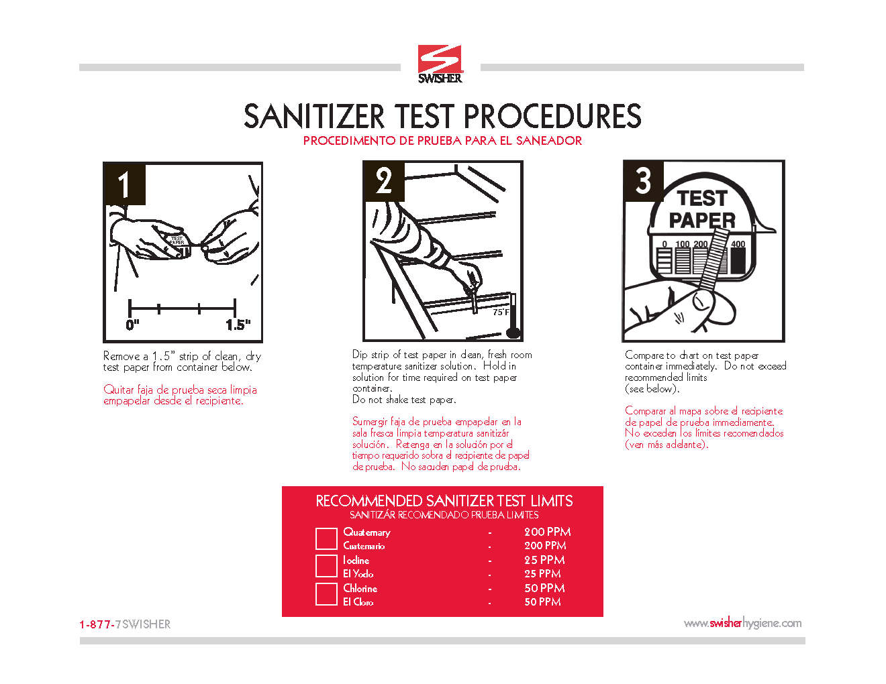

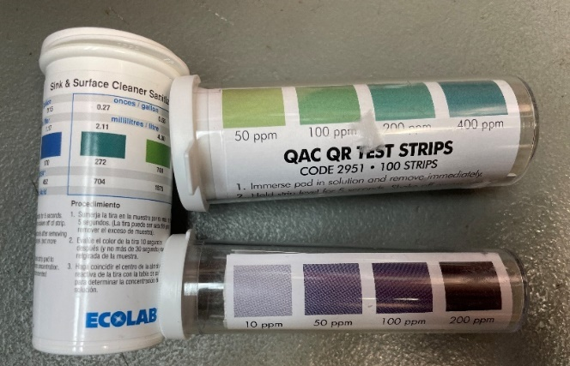

Cleaning and Breakdown of Equipment

Floors are swept with a designated broom for the BOH, applied appropriate floor cleaning chemical, and scrubbed with a deck brush. Squeegee any remaining water into the nearest floor drain.

Mops should be washed in hot water and hung to dry. Mop buckets should be rinsed and stored immediately after use.

Invert all pots and pans, food storage containers, and trays after cleaning. Allow them to air dry.

All kitchen equipment should be maintained and cleaned on a regularly scheduled basis. (See Daily/Weekly Side Work Chart)

All food contact surfaces, and kitchenware should be washed, rinsed, sanitized and air-dried after each use or after an extended period of non-use.

All cleaning products, insecticides, and chemicals must be stored away from food product and properly labeled. A SDS book should be present to hold all sheets for the chemicals in use.

Cooler and freezer cleanliness and organization should be maintained at all times.

All items need labeled, dated and rotated.
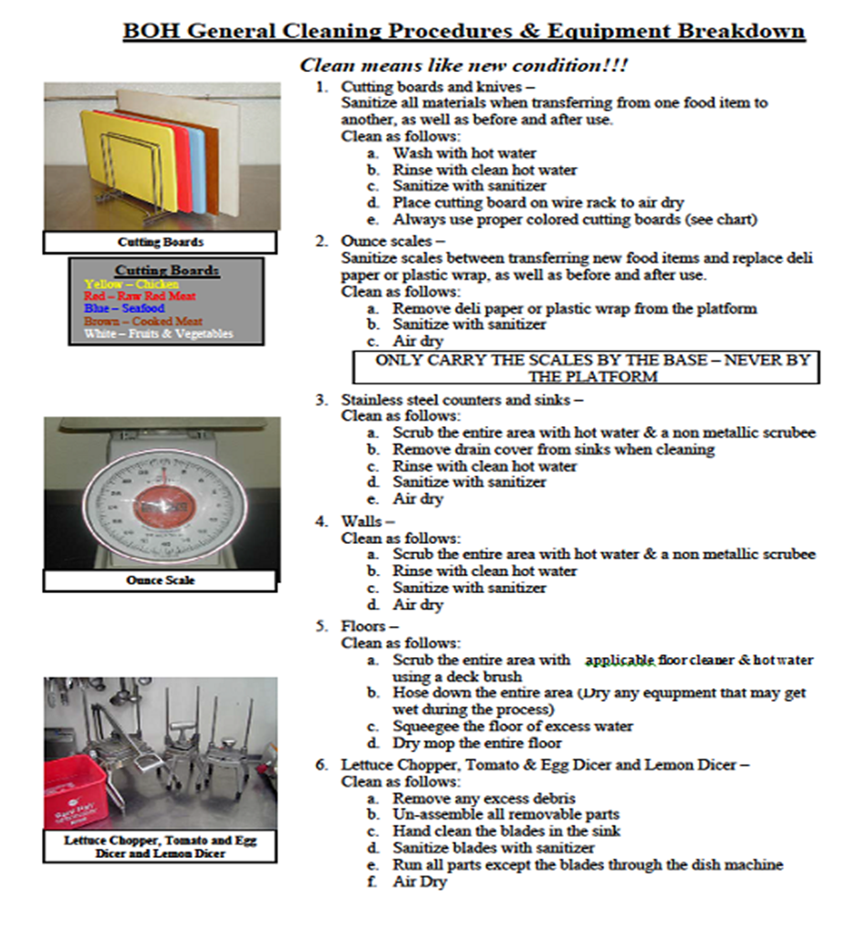

Labeling and Dating
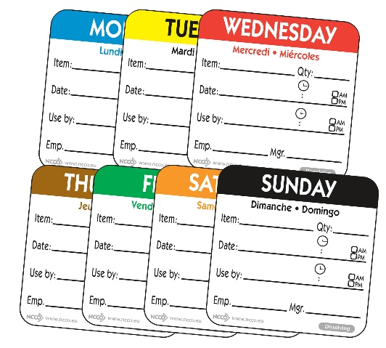
We use labels and “Day Dots” on our products to maintain correct
“in and out” times and shelf lives. We day dot with today’s color of dot.
This assists as a “red flag” when checking prep levels. If it is Monday morning,
and we are doing our Prep Sheet, anything with a day dot that is past its shelf
life need to be disposed of.

Waste Control

Food waste or food loss is food that is discarded or cannot be used. The causes of food waste or loss are numerous, and occur at the stages of production, processing, retailing and consumption. Besides the meat room, the broiler area has a huge impact on waste control. High dollar proteins are prepared at this station and need to be controlled at all times.

Listed below are some ways to help achieve our waste control goal:

Measuring- always use measuring tools when producing product (spoons, cups, ladles, scales). Do not over or under portion.

Storing Products- always follow proper cool down procedures. Products should cool to 40 degrees or below within 4 hours. Always use an ice bath. Not following storing or cooling procedures can cause spoilage or food borne illnesses. Remember to cover the item once it is properly cooled. Always store products properly. Not covering products after cooling can cause them to pick up odors or possibly cause spoilage.

Label and Date All Products upon Receiving or Production- Day dots and labels are necessary to ensure we are using the First In, First Out (FIFO) method for all products and that all products being served are within the standards for holding times.

Rotation- Products not getting dated or rotated can get lost in the walk-in and cause spoilage. What could be worse are sub-par products reaching a guest causing dissatisfaction or a non-returning guest.

Scraping- We must always use a rubber scraper/spatula to scrape cans, containers, and pans to get the best possible yield from all products. If we consistently throw away small amounts or portions of food from the bottom of the containers, it will add up to large amounts of money by the end of the month.

Correct Weights- Always use a scale to weigh an item properly. Remember, line cooks should periodically check themselves for accuracy. Follow proper specs and portion manuals.

Product Usage- Always get as much yield as possible from all items. Follow correct food handling procedures for coring and trimming vegetables (e.g., sliced and diced tomatoes). Always avoid product waste when possible.

Temperature- All refrigeration equipment and coolers must have working thermometers. Check all coolers throughout the workday and especially at line check time. To maintain temperatures all pans should be no more than ¾ full.

Cody’s Original Roadhouse Prep Day 2 Quiz
Name: _________________________________ Score ______/10
- Match the following measurements
- 3 teaspoons ______ 1 quart
- 4 tablespoons ______ 16 oz.
- 2 cups ______ 1 quart
- 4 cups ______ 1 pint
- 2 pints ______ 1 gallon
- 4 quarts ______ 1 tablespoon
- 1 pound ______ ¼ cup

- How often should the sani bucket be changed?
- Every 30 minutes
- Once an hour
- Once every 2 hours
- Once a shift

- Cutting boards and knives should be cleaned and sanitized___________________________

- When labeling products, we use a day dot. This will be the day the product
- Is made
- Is used
- Expires
- None of the above

- As a prep cook, you can help control waste by _____________________________________
___________________________________________________________________________

- The weekly/ daily cleaning chart is to help maintain and clean
- Produce
- Floors
- Knives
- Equipment

- All food items should be
- Stocked and cleaned
- Labeled, dated and rotated
- Made fresh daily
- Dumped out at night

- All chemicals should be stored
- In dry storage
- In the walk in
- In the prep area
- Away from food

- The blades from the lettuce chopper, tomato & egg dicer, and lemon slicer should be run through the dishwasher.
True or False

- You should use a ___________________ or _____________________ to thoroughly empty a can or container to get the best yield.

Trainee Evaluation
Day 2

(Completed by trainer with trainee present and signed off by manager)

Trainee arrived to work on time? YES NO
Trainee arrived in proper uniform? YES NO
Trainee spent allocated time cooking alongside trainer? YES NO
Was trainee involved and attentive to all training? YES NO
Does trainee accept constructive feedback? YES NO
Does trainee exhibit knowledge and understanding of sanitizing, cleaning, labels and dates, and waste? YES NO
If not, where did the trainee seem to need the most work? (Re-visit tomorrow)
__________________________________________________________________________________________________________
Notes for next day’s training/areas to focus on:
___________________________________________________________________________________________________________

Trainee Name________________________ Signature__________________
Trainer Name________________________ Signature__________________
Manager Signature____________________ Date____________

DAY 3
Class Topics-
- HACCP Standards (Safely Heating/Cooling)
- Health and Safety Standards
- Foodborne Illnesses
Follow Topics-
- Trainee completes any prep for the day with trainer coaching and working alongside.
- Trainer reviews prep sheets, weight vs volume measurements.
Cody’s Original Roadhouse Signature Dishes to Share During Classroom-
Order your choice of one combo: BBQ ½ Chicken & ½ Slab of Ribs, 5 Garlic Fried Shrimp & ½ Slab of Ribs, or Prime Rib of Beef & 5 Large Shrimp

HACCP Standards (Safely Heating/Cooling)
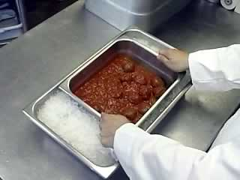
Hazard Analysis and Critical Control Points (or HACCP) is a system that helps food business operators look at how they handle food and introduces procedures to make sure that the food produced is safe to eat. The HACCP creates measurements to reduce these risks to a safe level. Basically, the focus is on controlling the “critical control points” in food-- pertaining to how it is heated and cooled for production. Controlling these points in our business is crucial to our safety and success.
"Temperature Danger Zone"
Food has a temperature danger zone (41 °F–140 °F). Bacteria grows rapidly in the temperature danger zone, so the times that food can be at that temperature has to be minimized to limit bacterial growth.
Keep hot food hot — at or above 140 °F. Place cooked food in chafing dishes, preheated steam tables, warming trays, and/or slow cookers.
Keep cold food cold — at or below 41 °F. Place food containers in refrigeration or on ice.
Rapid Cooling Applications
Select a rapid cooling method to speed the cooling process.
- Place the container of food in an ice water bath and stir occasionally. Follow timelines.
- Separate food into smaller or thinner portions and chill separately to expedite cooling. This process can be combined with the previous method to achieve optimal results.
- Use a quick-chill unit such as a blast chiller. (if available)
Important cooling temperatures and times include the following:
- Hot food must be cooled from 140 °F–70 °F within 2 hours.
- Hot food must be cooled from 70 °F–41 °F in an additional 4 hours.
Reheating
Foods should be reheated thoroughly to an internal temperature of 165 °F. Food can only be reheated once. Therefore, a product can only be heated twice in its shelf life. First heat is during initial preparation, second heat is upon the reheat.

Pull Thaw Procedure
There are 3 acceptable methods for safely thawing food:
- Under refrigeration (Preferred method)
- Under cold running water. (CANNOT be thawed in standing water!)
- As part of the cooking process
The key to properly thawing is properly preparing. Plan ahead, know what you need, and thaw items safely. Daily pars need to be in place to successfully thaw product.
Health and Safety Standards

The food supply in the United States is among the safest in the world. However, when certain disease-causing bacteria or pathogens contaminate food, they can cause foodborne illness, often called “food poisoning.”
The Federal government estimates that there are about 48 million cases of foodborne illness annually – the equivalent of sickening 1 in 6 Americans each year. And each year these illnesses result in an estimated 128,000 hospitalizations and 3,000 deaths.
Since foodborne illness can be serious — or even fatal — it is important for you to know and practice safe food handling behaviors to help reduce your risk of accidentally getting sick from contaminated food.

Foodborne Illness Is Serious Business
Foodborne illness can strike anyone. However, some people are at a higher risk for developing foodborne illness. These include pregnant women, young children, older adults and people with weakened immune systems.
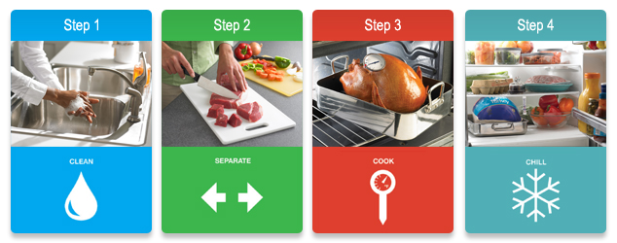

Four Steps to Food Safety
1. CLEAN: Wash hands and surfaces often
Bacteria can be spread throughout the kitchen and get onto hands, cutting boards, utensils, counter tops and food.
To ensure that your hands and surfaces are clean, be sure to:

- Wash your hands with warm water and soap for at least 20 seconds before and after handling food and after using the bathroom, changing diapers and handling pets.
- Wash your cutting boards, dishes, utensils and counter tops with hot soapy water after preparing each food item and before you go on to the next food.
- Rinse fresh fruits and vegetables under running tap water, including those with skins and rinds that are not eaten.
- Rub firm-skin fruits and vegetables under running tap water or scrub with a clean vegetable brush while rinsing with running tap water.
- With canned goods, remember to clean lids before opening.

2. SEPARATE: Separate raw meats from other foods
Cross-contamination can occur when bacteria are spread from one food product to another. This is especially common when handling raw meat, poultry, seafood and eggs. The key is to keep these foods—and their juices—away from ready-to-eat foods.
To prevent cross-contamination, remember to:
- Separate raw meat, poultry, seafood and eggs from other foods in your refrigerator.
- Use one cutting board for fresh produce and a separate one for raw meat, poultry and seafood.
- Never place cooked food on a plate that previously held raw meat, poultry, seafood or eggs.
- Don’t reuse marinades used on raw foods unless you bring them to a boil first.

3. COOK: Cook to the right temperatures
Food is safely cooked when it reaches a high enough internal temperature to kill the harmful bacteria that cause illness. Refer to the Safe Cooking Temperatures Chart for the proper internal temperatures. To ensure that your foods are cooked safely, always:
- Use a food thermometer to measure the internal temperature of cooked foods. Check the internal temperature in several places to make sure that the meat, poultry, seafood, eggs or dishes containing eggs are cooked to safe minimum internal temperatures as shown in the Safe Cooking Temperatures Chart.
- Cook ground meat or ground poultry until it reaches a safe internal temperature. Color is not a reliable indicator of doneness.
- Cook eggs until the yolk and white are firm. Only use recipes in which eggs are cooked or heated thoroughly.
- When cooking in a microwave oven, cover food, stir, and rotate for even cooking. If there is no turntable, rotate the dish by hand once or twice during cooking. Always allow standing time, which completes the cooking, before checking the internal temperature with a food thermometer. Food is done when it reaches the safe minimum internal temperature.
- Bring sauces, soups and gravy to a boil when reheating.

4. CHILL: Refrigerate foods promptly
Refrigerate foods quickly because cold temperatures slow the growth of harmful bacteria. Do not over-stuff the refrigerator. Cold air must circulate to help keep food safe. Keeping a constant refrigerator temperature of 41ºF or below is one of the most effective ways to reduce the risk of foodborne illness. Use an appliance thermometer to be sure the temperature is consistently 41ºF or below and the freezer temperature is 0ºF or below.
To chill foods properly:
- Refrigerate or freeze meat, poultry, eggs, seafood and other perishables within 2 hours of cooking or purchasing. Refrigerate within 1 hour if the temperature outside is above 90ºF.
- Never thaw food at room temperature, such as on the countertop. Food must be kept at a safe temperature during thawing. There are three safe ways to defrost food: in the refrigerator, in cold water, and in the microwave. Food thawed in cold water or in the microwave should be cooked immediately.
- Always marinate food in the refrigerator.
- Divide large amounts of leftovers into shallow containers for quicker cooling in the refrigerator.

Hierarchy of foods

CUTTING BOARD and knife COLOR CHART

Separate colors of cutting boards and knives are used to prevent cross contamination. Cross-contamination is the physical movement or transfer of harmful bacteria from one person, object or place to another.
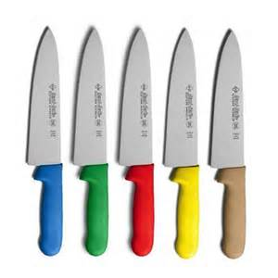
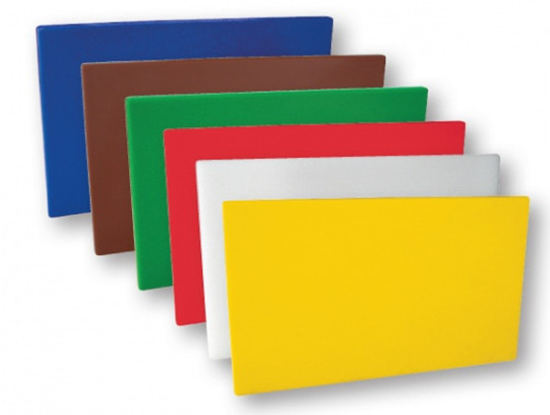
Food and kitchen tools and surfaces may become contaminated from raw food products (e.g., meat and poultry). Microbes can be transferred from one food to another by using the same knife, cutting board or other utensil without washing the surface or utensil in between uses. A food that is fully cooked can become re-contaminated if it touches other raw foods or drippings from raw foods that contain pathogens.

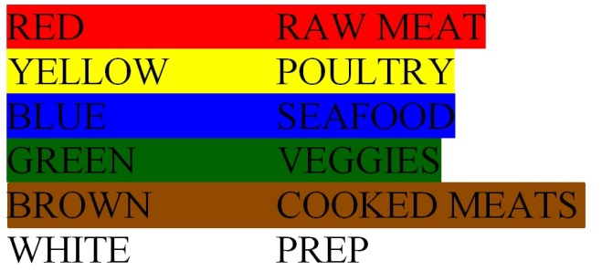

Foodborne Illness

Foodborne illness is caused by consuming food or beverages that are contaminated by disease-causing microbes (pathogens).
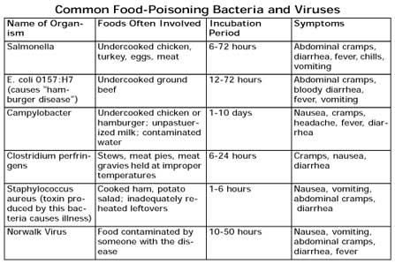

Cody’s Original Roadhouse Prep Day 3 Quiz
Name: _________________________________ Score ______/10
- The danger zone for food is between ______ and _____ degrees F.

- Match the correct temperature to the correct HACCP standard
- 41 degrees F- 140 degrees F _____ Keep hot food hot
- At or above140 degrees _____ Danger zone
- At or below 41 degrees F _____ Keep cold food cold

- Hot food must be cooled from 140 degrees F -70 degrees F within ____ hours.
- 1
- 2
- 3
- 4

- Hot food must be cooled from 70 degrees F- 41 degrees F within an additional ____ hours.
- 1
- 2
- 3
- 4

- The preferred method to thaw food is to
- Leave in standing water
- Thaw in hot water
- Under Refrigeration
- Cook from frozen

- Reheated food must be heated to an internal temperature of ______ degrees F.
- 150
- 155
- 160
- 165

- The four steps to food safety are
- Wash hands, surfaces, produce and lids on cans
- Separate raw meat from seafood, poultry, eggs and from other foods
- Cook food to the correct temperatures, chill and refrigerate promptly
- All of the above

- Always place _______ foods below _________________________ cooked foods.

- A red cutting board should be used for
- Poultry
- Seafood
- Produce
- Raw Meat

- Common forms of food-borne illness is caused from
- Undercooked foods
- Inadequately reheated foods
- Food contaminated from someone with disease
- All of the above

Trainee Evaluation
Day 3

(Completed by trainer with trainee present and signed off by manager)

Trainee arrived to work on time? YES NO
Trainee arrived in proper uniform? YES NO
Trainee spent allocated time cooking alongside trainer? YES NO
Was trainee involved and attentive to all training? YES NO
Does trainee accept constructive feedback? YES NO
Does trainee exhibit knowledge and understanding of HACCP, Health & Safety Standards? YES NO
If not, where did the trainee seem to need the most work? (Re-visit tomorrow)
__________________________________________________________________________________________________________
Notes for next day’s training/areas to focus on:
___________________________________________________________________________________________________________

Trainee Name________________________ Signature__________________
Trainer Name________________________ Signature__________________
Manager Signature____________________ Date____________
Manager Signature

Day 4
Class Topics-
- Alto Sham
- Prep Clean Up Processes

Follow Topics-
- Trainee completes any prep for the day with trainer coaching and working alongside.

Cody’s Original Roadhouse Signature Dishes to Share During Classroom-
Order a slice or Chocolate or Carrot Towering Cake and choice of 1-Chicken Fried Chicken Sandwich 8oz Buffalo Style, Fish Sandwich or Cody’s Steak Burger to share.

Alto Shaam
The Alto Sham oven is a slow cooking, low temperature method of roasting. The advantages of using a slow cooking method over a quicker process such as a convection oven are:

1. Better flavor and nutrition are generally the results of food cooked at low temperatures.
2. Foods cooked at low temperatures created optimum enzyme action, which in turn allows the meat to be more tender and flavorful.
3. Meat cooked at low temperatures maintains more juice because the meat cell is not easily ruptured.
4. Slow, low temperature cooking results in a more uniformly finished product with less shrinkage. Less shrinkage is turn results in more cuts per rib.
5. The Alto Sham requires less total energy consumption than a convection oven and also does not require the use of a hood or exhaust fan.

The Alto Sham works through two basic cycles, which are called "cooking" and "holding". These two cycles work together to bring the product up to the optimum degree of doneness.

The time requirements of the cooking cycle will vary with the amount of product placed in the oven. When oven is full, it may be necessary to rotate pans - bottom shelf to top shelf to insure even cooking.

It should also be noted that the Alto Sham will switch from the cooking cycle to the holding cycle automatically once the timer runs out.

TURNING ON THE ALTO SHAM
Under normal conditions the temperature setting for the cook and hold cycles will have been set from the time the oven was first used. However, the temperatures should be checked to be sure no one has moved the dials. They should be set as follows:

- Cooking temperature - 300°F
- Holding temperature- 140°F

Once you are sure the temperature settings are correct you are ready to activate the oven. The steps are as follows:

A. Before turning the oven on:
1. Make sure the drip pans are in their proper location.
The side racks and shelves are in the oven.
2. Each oven cavity has two vents on the door, one on top and one on the bottom.
The bottom vent should be closed and the top vent half open.

B. Turning the oven on:
1. Flip the oven on/off switch to ON for the cavity, which you will be using.
Switching the switch ON activates the holding cycle but will not activate the cooking cycle. Turning the timer activates the cooking cycle.
2. Turn the timer past five hours to activate the cooking cycle. The reason we go past five hours is that the timer is more accurate if you turn it back to the cooking time you will be using
3. Now that the ovens are working it is critical that you allow them to preheat at least thirty (30) minutes. While the oven is preheating you will be getting the product ready to be loaded into the oven.

NOTE: Always make sure you have activated the correct cavity, upper or lower and that you have not turned the switch on for the upper cavity and the timer for the lower cavity (or vice versa).

The Alto-Shaam™ is a holding cabinet and cooking unit. Note the controls on the unit (cook cycle vs hold cycle). If product is held in the cabinet, make sure the product that goes in there is hot and ready to serve! It CANNOT go into a holding cabinet cold, just like cold pans of food cannot be dropped into a steam well cold to heat up! Remember, almost all of our products have a maximum hot-hold time of 4 hours.
Prep Cleanup Process

Prep Area
- Clean and organize under prep tables
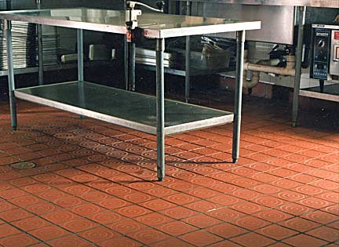
- Clean, wipe and dry sinks and walls
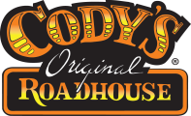
- Clean and sanitize countertops
- Empty and re-line all trash cans
- Clean and organize dry storage area
- Sweep and mop prep area floor
- Clean and replace all utensils, equipment and measuring tools

Freezer
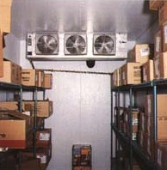
- Verify that temperature is between 0- and 10-degrees F.
- Clear the floor
- Organize shelves
- Rotate products, oldest products in front, discard products that have exceeded their pull date
- Sweep and clean floor

Walk-in Cooler
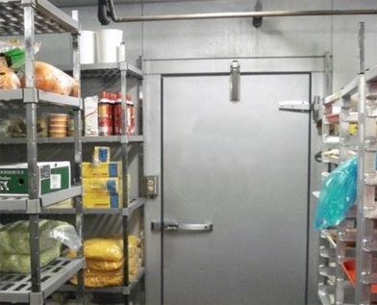
- Verify that temperature is between 36 and 40 degrees F.
- Ensure that all products are covered and in the proper containers
- Organize shelves, ensure that all containers are labeled
- Rotate products, oldest in front, expired products need to be brought to the KM
- Clean and wipe racks from top to bottom
- Sweep, scrub and dry mop floor

Cody’s Original Roadhouse Prep Final Test
Name: _________________________________ Score ______/40

- The Alto Shaam is a _________________________, _________________________ method of roasting.

- The Alto Shaam can be used to heat food. True or False

- Almost all of our products have a hot hold time of _____ hours.
- 1
- 2
- 4
- 8

- Slow, low temperature cooking results in a more uniformly _____________ with ________ shrinkage.

- Which is not part of the prep clean up?
A) Clean and organize the prep table
B) Clean, wipe, dry sinks and walls
C) Rotate products
D) Taste products approaching their expiration dates

- The batch size and yield can be located in the
A) Recipe book
B) Spec book
C) Red book
D) Bar book

- We use a _______________________ to place food items on the platform of a scale.

- The dial on the scale should be adjusted to zero once a _____________________ is placed on the scale to accurately weigh an item.

- We follow the recipes to ensure
A) Quality & Consistency
B) Proper Labeling
C) Proper Temperature
D) Proper Preparation

- You should clean all prep areas
A) Whenever you finish all prep
B) At your earliest convenience
C) Immediately after use
D) Weekly

- FIFO means First in, First Out? True or False

- The prep sheet is completed by the
A) Kitchen Manager
B) Prep Cook
C) Meat Cutter
D) Line Cook

13. Beef roasts should reach a minimum internal temperature of _____ degrees F for ______ minutes.

14. Match the correct color of cutting board to the proper item
______ Red A) Poultry
______ Yellow B) Seafood
______ Blue C) Cooked Meats
______ Green D) Raw Meats
______ Brown E) Prep
______ White F) Veggies

- We have 2 recipe books, one for _________________ and one for _______________________.

- Freezer temperatures should be between 0 and 10 degrees F. True or False

- Walk in cooler temperatures should be between 30 and 40 degrees F. True or False

- Food can only be heated _____ time(s) in its shelf life.
A) One
B) Two
C) Three
D) Four

- Weight = something you can put on a scale to weigh True or False

- Volume = something you put in a utensil of measurement True or False

- Liquid and dry measuring utensils are not interchangeable. True or False

- Where are cooked, ready to eat foods stored on the shelf?
A) Top shelf
B) Bottom shelf
C) With the produce
D) Under raw meats

- What items are placed on the product container before storing to ensure freshness?
- __________________ 2.______________________ 3._____________________

- As a line cook you should periodically check yourself for accuracy. True or False
- The prep area has a huge impact on _____________.
A) Scheduling
B) Waste Control
C) Labor Costs
D) Employee Moral

- Which is NOT a rapid cooling method?
A) Place in an ice bath and stir occasionally
B) Separate into smaller or thinner portions
C) Use a blast chiller (if available)
D) Place in the walk in cooler immediately

- Food can be thawed by sitting out on a counter. True or False

- You should use ____________________ to make sure the internal temperature has been reached.
A) Your finger
B) A thermometer
C) A knife
D) All of the above

- Food should be refrigerated within _____ hours of cooking or purchasing or _____ hour if it above 90 degrees F outside.

- Food should never thaw _____________.
A) In the microwave
B) Under cold running water
C) On the counter
D) In the refrigerator

- What is the first thing you should do after clocking in?
A) Eat
B) Text
C) Wash your hands
D) Catch up with your co-workers

- What is the first thing you should set up on your station?
A) Sani bucket
B) A drink
C) A radio
D) Trash can

- We always use a recipe book when prepping items. True or False

- List the 4 steps to food safety.
- _________________________ 3. _______________________
- _________________________ 4. _______________________

- Food thawed in cold water or in the microwave should be cooked immediately. True or False

- Raw poultry should be placed on the _________________________ shelf when storing.

- The timer must be turned past ______ to activate the cooking cycle.

- The oven must preheat for at least ______ minutes to have an accurate temperature.

- Poultry should reach a minimum internal temperature of _____ degrees F for at least _____ seconds.

- Ground meats (including ground beef and ground pork) should reach a minimum internal temperature of _______ degrees for _____ seconds.

